MED D - Blue MedicareRx (NEJE) - Enrollee Attestation for Future Enrollment (TRC 127 Attestation)

High Level Process
General Information
Process
RxEnroll Care Downtime
Closing the Call
Note Templates
Resolution Time
Related Documents

Description: This document outlines the process the Blue MedicareRx (NEJE) CCR will follow when receiving a call regarding the beneficiary receiving a TRC 127 letter or a TRC 127 rejection. When a TRC 127 is received from CMS, the MED D plan sponsor sends the prospective enrollee a letter requesting attestation or confirmation of his/her enrollment into a prescription drug plan that is separate from his/her existing employer group, retiree or union group benefits.

High Level Process
- Confirm 127 displays in the Transaction Reply field under the MED D Inquiry tab in PeopleSafe.  - If yes, proceed to next step.  - If no, this is not a TRC127. Handle call accordingly and proceed to appropriate work instructions. | Notes:  - NEJE CCRs, follow the process outlined in this document.
- Review the Last 12 months of Medicare D Communications for DCENR or DDMCO letter.
- If DCENR, proceed to next step.
- If DDMCO, a new enrollment application will need to be submitted since the time period to provide attestation or confirm enrollment application has passed.
- If neither DCENR nor DDMCO, this is not a TRC127. Handle call accordingly and proceed to appropriate work instructions.
- Access RxEnroll Care to complete TRC 127 attestation. | Note: In the event RxEnroll Care is down or unavailable, refer to RxEnroll Care Downtime.
- Close the call.

Top of the Document

General Information
Employer, Retiree and Union Group plans make decisions annually regarding benefit coverage that is provided to their employees. This benefit coverage may include a variety of options, such as medical, prescription, dental, vision, etc.

When an employee becomes Medicare eligible, the Employer, Retiree or Union Group may make one of three decisions:
- Continue to provide benefits
- Drop all benefits
- Offer certain benefits if the employee selects a specific Medicare plan sponsor

When an enrollment request is submitted by a Medicare plan sponsor, a Beneficiary Eligibility Query (BEQ) is performed by the Centers for Medicare and Medicaid Services (CMS). If it is determined that there is Employer, Retiree or Union coverage that coincides with the enrollment, this will result in a Transaction Reply Code (TRC) 127 rejection sent from CMS back to the plan sponsor.

Note: In the cases of the employer group, retiree plan or union group dropping all benefits,
- Medicare may not have received information from the health plan, advising the beneficiary’s employer group, retiree plan or union group coverage is ending.
- Medicare-eligible beneficiaries must enroll into a creditable prescription drug plan to avoid incurring a late enrollment penalty.

When a prospective enrollee chooses a prescription drug plan outside of his/her existing employer group, retiree or union group benefits, he/she will lose any associated benefits (Example: Medical, dental, vision, etc.). This would also apply to anyone else covered under the same Plan.

Blue MedicareRx (NEJE) depends on the state they reside in:
- MA: 1-866-832-9775
- CT: 1-866-832-9702
- RI: 1-888-496-4174
- VT: 1-888-496-4178

Top of the Document

Process

Perform the following steps:
Step | Action
1 | From the Medicare D Inquiry Tab - Participant Details section of PeopleSafe, confirm 127 displays in the Transaction Reply.  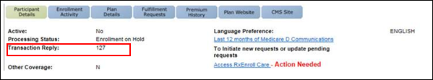  Note: If the MED D Inquiry Tab is selected and the below error message appears, select New next to the MED D Inquiry tab to search for the beneficiary and view the Transaction Reply field.  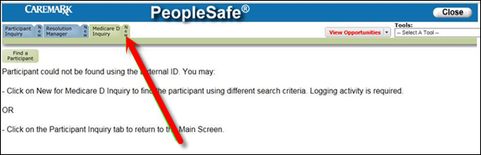  Return to High Level Process
1 | If… | Then…
1 | Yes, 127 is displayed | Proceed to the next step.
1 | No | This is not a TRC 127 situation. Handle call accordingly and proceed to appropriate work instruction.  Note: If the beneficiary is not in PeopleSafe, it is not a TRC 127 attestation.
2 | Review the Last 12 months of Medicare D Communications and locate recent letters sent to the beneficiary.  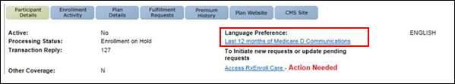  Return to High Level Process
2 | If... |  | Then...
2 | DCENR letter is found |  | Proceed to Step 3.
2 | DDMCO letter is found |  | - Thank you for contacting Customer Care regarding your recently submitted enrollment application.  - The time period provided to attest or confirm your enrollment application has passed.  - At this time, you will need to submit a new application.  - Can I ask if you used an agent to submit your previous application?
2 |  |  | If... | Then...
2 |  |  | Yes | - Contact your agent to complete another application as soon as possible.  - Please be sure to call back in about a week after the new enrollment has been submitted by the agent to attest that you do want this plan to ensure your enrollment is completed successfully.  Note: The CCR is referring the beneficiary back to their agent in order to ensure the agent is able to retain their commission for the enrollment application.  - If the enrollment application is taken by the CCR, the Enrollment Team will need to work with the agent after the enrollment is complete in order to ensure the commission is transferred properly.
2 |  |  | No | I can submit another application for enrollment for you. Please call us back next week to provide the necessary attestation to ensure your enrollment is completed successfully.
2 | Neither DCENR nor DDMCO is found |  | This is not a TRC 127 situation. Handle call accordingly and proceed to appropriate work instruction.  Locate letter in Last 12 Month Communication on the Medicare D Inquiry Tab in PeopleSafe. Handle call accordingly.  If there is no history of the enrollment, DO NOT refer the beneficiary to Medicare.
3 | From the Medicare D Inquiry Tab - Participant Details of PeopleSafe, click on the Access RxEnroll Care link.  Note: If there are additional tasks listed under Action Areas complete each Action using MED D - Blue MedicareRx (NEJE) Commonly Used Work Instructions Index.    Result: The RxEnroll Care landing page displays.  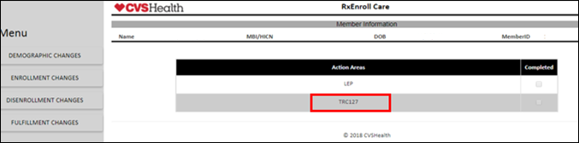  Return to High Level Process
3 | If... |  |  |  | Then...
3 | The beneficiary has a pending TRC 127 |  |  |  | Select TRC 127 under Action Areas.
3 | If the beneficiary is calling about receiving a TRC 127 Letter or an Employer Subsidy Waiver Letter |  |  |  | Select ENROLLMENT CHANGES under the Menu on the left side of the screen and click TRC 127.
4 | Read the scripting in the RxEnroll Care application to the beneficiary.  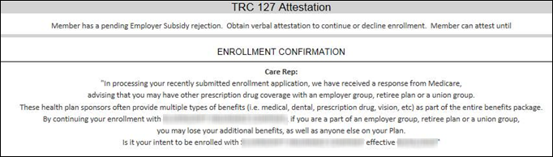  Return to High Level Process
4 | If... | Then...
4 | Yes | - Select Continue Enrollment.  - Follow the prompt provided in the RxEnroll Care application.  - Enter the following Comments in the pop up box: Beneficiary accepts enrollment.  - Click the Submit button to process the beneficiary’s request.  Note: Copy and Paste comments into the Participant Inquiry Tab in PeopleSafe.
4 | No | - Select Decline Enrollment.  - Follow the prompt provided in the RxEnroll Care application.  - Enter the following Comments in the pop up box: Beneficiary declines enrollment.  - Click the Submit button to process the beneficiary’s request.  Note: Copy and Paste comments into the Participant Inquiry Tab in PeopleSafe.
5 | Proceed to Closing the Call.  Return to High Level Process

Top of the Document

RxEnroll Care Downtime

Perform the following steps:
Step | Action
1 | Confirm 127 displays in the Transaction Reply field under the MED D Inquiry tab in PeopleSafe.  Note: If the MED D Inquiry Tab is selected and the below error message appears, select New next to the MED D Inquiry tab to search for the beneficiary and view the Transaction Reply field.
2 | Locate the TRC notification letter sent to the beneficiary in 12 month Communication History link in Medicare D Inquiry tab in PeopleSafe. Letter code is DCENR.
2 | If... |  | Then...
2 | DCENR letter is found |  | Proceed to Step 3.  Note: Click here to view the MED D - TRC127 letter sample Y0080_52303_ENR.
2 | DDMCO letter is found |  | - Thank you for contacting Customer Care regarding your recently submitted enrollment application.  - The time period provided to attest or confirm your enrollment application has passed.  - At this time, you will need to submit a new application.  - Can I ask if you used an agent to submit your previous application?
2 |  |  | If... | Then...
2 |  |  | Yes | - Contact your agent to complete another application as soon as possible.  - Please be sure to call back in about a week after the new enrollment has been submitted by the agent to attest that you do want this plan to ensure your enrollment is completed successfully.  Note: The CCR is referring the beneficiary back to their agent in order to ensure the agent is able to retain their commission for the enrollment application.  - If the enrollment application is taken by the CCR, the Enrollment Team will need to work with the agent after the enrollment is complete in order to ensure the commission is transferred properly.
2 |  |  | No | I can submit another application for enrollment for you. Please call us back next week to provide the necessary attestation to ensure your enrollment is completed successfully.
2 | Neither DCENR nor DDMCO is found |  | This is not a TRC 127 situation.  Locate letter in Last 12 Month Communication on the Medicare D Inquiry Tab in PeopleSafe. Handle call accordingly and refer to MED D - Blue MedicareRx (NEJE) Commonly Used Work Instructions Index.  If there is no history of the enrollment, DO NOT refer the beneficiary to Medicare.  Proceed to Closing the Call.
3 | - In processing your recently submitted enrollment application, we have received a response from Medicare advising that you may have other prescription drug coverage with an employer group, retiree plan or a union group.  - These health plan sponsors often provide multiple types of benefits (Example: Medical, dental, prescription drug, vision, etc.) as part of the entire benefits package.  - If you are a part of an employer group, retiree plan or a union group, you and anyone else covered under your Plan may lose your additional benefits if you continue your enrollment with <Blue MedicareRx (NEJE).  - Would you like to continue with your enrollment?
3 | If... | Then...
3 | Yes | Proceed to next step.
3 | No | By choosing to decline your enrollment, you will not be a part of the <Blue MedicareRx (NEJE)> prescription drug plan.  Proceed to Closing the Call.
4 | Submit the following RM Task in PeopleSafe:  Task Category: Med D Enrollment - Enrollment  Task Type: TRC 127  Queue: Med D Enrollment Task  The CCR MUST include the following pieces of information:  - <Caller’s Name> contacted Customer Care < (if not the beneficiary, provide Legal Rep or POA (full name, address and phone number, and relationship to the beneficiary) on behalf of the beneficiary> before deadline of <insert deadline date here> and he/she intends to enroll into the requested <Blue MedicareRx (NEJE)> plan. The beneficiary understands the consequences of continuing his/her enrollment into <Blue MedicareRx (NEJE)>.  - (If applicable) The beneficiary’s employer group, retiree plan or union group is discontinuing his/her prescription drug coverage.  Refer to the MED D - SilverScript and Blue MedicareRx (NEJE) - Enrollment Related RM Tasks.
5 | Copy and paste the note from the RM Task into your notepad for your Capture Activity note.
6 | Proceed to Closing the Call.

Top of the Document

Closing the Call

Perform the following:
Step | Action
1 | From the Participant Inquiry tab, click on the Capture Activity button on the bottom left of the screen.
2 | In the Log Activity Notes field, add a note detailing the TRC 127 Attestation request.  Refer to Note Templates.  - When attesting to continue with enrollment:  - 700 = Eligibility Update Request (if on file)  - 701 = Eligibility Verification (if not on file)  - When cancelling enrollment:  - 700 = Eligibility Update Request (if on file)  - 701 = Eligibility Verification (if not on file)
3 | Click on Save Changes.
4 | - Thank you for your time today.  - As a quality measure, have I fully answered and resolved <your/the beneficiary’s> question(s) to <your/the beneficiary’s> satisfaction?
4 | If… | Then…
4 | Yes | Close the call:  - Address any benefit issues.  - Document and close the call according to existing policies and procedures, including all options discussed. Refer to the MED D - Call Documentation work instruction.
4 | No | - Ask additional probing questions to attempt to resolve remaining questions or concerns.  - If unable to resolve the questions/concerns, transfer the call to a Supervisor.
5 | Transfer the beneficiary to the appropriate department as needed. (Licensed Enrollment Agent, Premium Billing, Senior Team, etc.)

Top of the Document

Note Templates

Use the chart below:
Scenario | Note Template
Continue with Enrollment | - <Caller’s Name> contacted Customer Care < (if not the beneficiary, provide Legal Rep or POA (full name, address and phone number, and relationship to the beneficiary) on behalf of the beneficiary> before deadline of <insert deadline date here> and he/she intends to enroll into the requested <Blue MedicareRx (NEJE)> plan. The beneficiary understands the consequences of continuing his/her enrollment into <Blue MedicareRx (NEJE)>.  - (If applicable) The beneficiary’s employer group, retiree plan or union group is discontinuing his/her prescription drug coverage.
Cancel Enrollment | - <Caller’s Name> contacted Customer Care < (if not the beneficiary, provide Legal Rep or POA (full name, address and phone number, and relationship to the beneficiary) on behalf of the beneficiary> before deadline of <insert deadline date here> and he/she intends to cancel the requested <Blue MedicareRx (NEJE)> enrollment.
Past the 30 day deadline | - <Caller’s Name> contacted Customer Care < (if not the beneficiary, provide Legal Rep or POA (full name, address and phone number, and relationship to the beneficiary) on behalf of the beneficiary> before deadline of <insert deadline date here> and he/she intends to enroll into the requested <Blue MedicareRx (NEJE)> enrollment.  - Beneficiary contacted the plan after the 30 day timeline and the enrollment has been denied.  - Submitted new enrollment.

Top of the Document

Resolution Time
4 business days
Top of the Document

Related Documents
Grievance Standard Verbiage (for use in Discussion with Beneficiary) section in MED D - Grievances in PeopleSafe for Health Plans, JE (formerly MHK Fusion)

Parent SOP: CALL-0048: Medicare Part D Customer Care Call Center Requirements-CVS Caremark Part D Services, L.L.C.
Abbreviations/Definitions: Abbreviations / Definitions

Top of the Document
Not to Be Reproduced or Disclosed to Others without Prior Written Approval
ELECTRONIC DATA = OFFICIAL VERSION - PAPER COPY = INFORMATIONAL ONLY

